Chapter 14, Problem 91.

For the “tank” circuit of Fig. 14.79, obtain the frequency response (voltage across the capacitor) using PSpice. Determine the resonant frequency of the circuit.

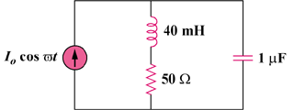

Figure 14.79
For Probs. 14.39, 14.71, and 14.91.

